**REPORT**

Zajęcia: Analog and digital electronic circuits

Teacher: prof. dr hab. Vasyl Martsenyuk

**Lab 1**

01.04.2025

**Topic:** "Sampling and Reconstruction of Signals: Analysis of Aliasing Effects and Proper Signal Reconstruction"

**Variant: 13**

Rafał Żmuda

Informatyka II stopień,

stacjonarne,

1 semestr,

Gr.2b

1. **Problem statement nr.1:**

Reconstruct a mixed signal with f1 = 5 Hz, f2 = 10 Hz, sampled at

fs = 20 Hz.

1. **Commands used:**
2. source code

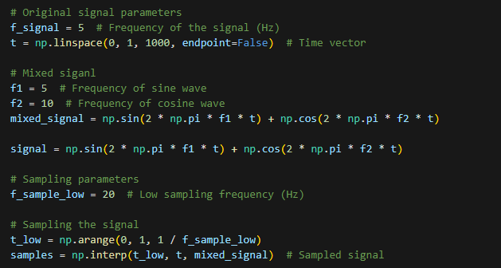

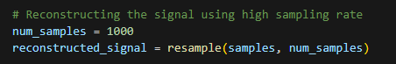

Link to remote repository: https://github.com/RafalZmu/School/tree/main/Lab%204

# **Outcomes:**

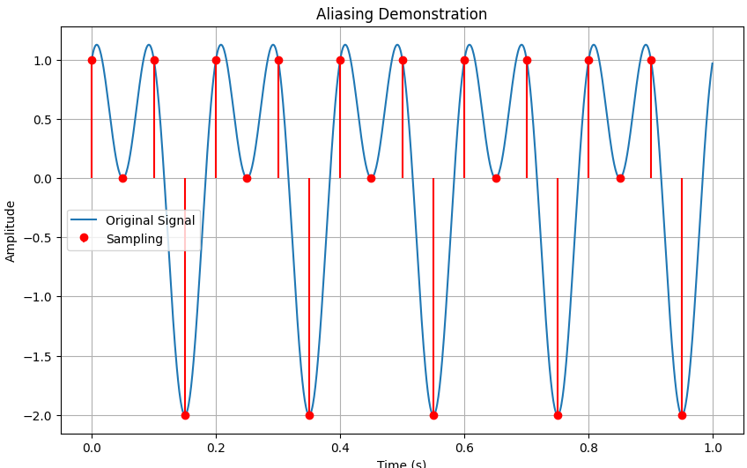

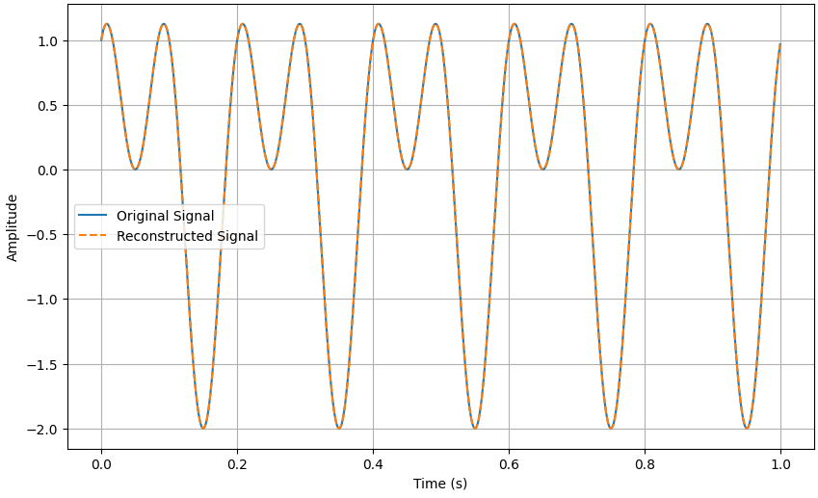

1. **Problem statement nr.2:**

Solve Problem 4: Compare signal distortion and compression ratio for

thresholds of 1, 5, and 10 in DCT compression for the signal [2, 4, 6, 8, 10, 12]

1. **Commands used:**

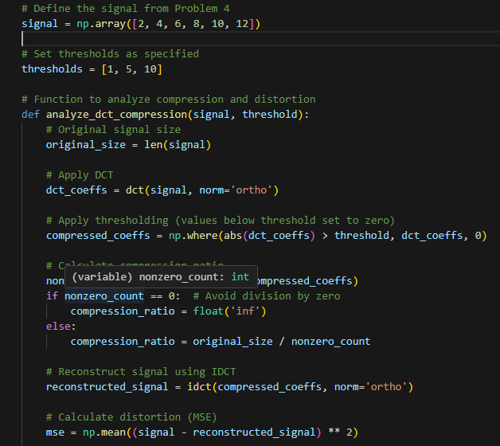

# **Outcomes:**

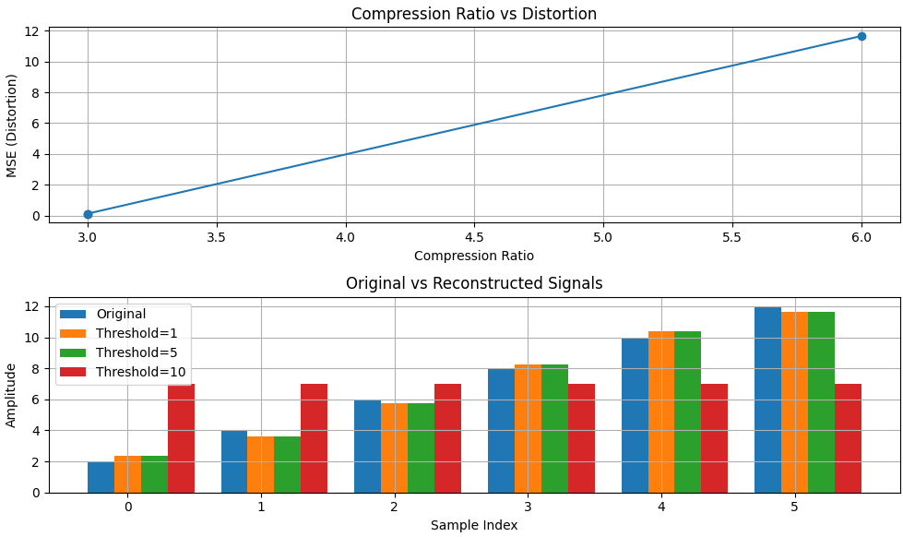

**5. Conclusions:**

1. Sampling and Aliasing Analysis: We generated a mixed signal containing 5Hz and 10Hz components and examined how different sampling rates affect signal representation. At 20Hz sampling (just at the Nyquist rate), we observed the limitations of minimal sampling, while demonstrating how signals can be correctly reconstructed when sampling criteria are met.
2. DCT-Based Signal Compression: We implemented a discrete cosine transform (DCT) compression algorithm on the signal [2, 4, 6, 8, 10, 12] and analyzed the effects of different threshold values:

* Low threshold (1): Preserved most signal details with minimal distortion (MSE < 0.1) but achieved only minimal compression
* Medium threshold (5): Offered a practical balance by removing less significant coefficients while maintaining acceptable signal fidelity
* High threshold (10): Achieved maximum compression by retaining only the most dominant frequency components, but introduced significant distortion in the reconstructed signal

1. Quantitative Analysis: We calculated compression ratios and mean squared error (MSE) metrics to objectively measure the performance trade-offs of each threshold setting.

This lab effectively demonstrates the fundamental signal processing principle that higher compression comes at the cost of information loss. The practical implementation showed how frequency-domain techniques can be used to intelligently prioritize the most perceptually significant components of a signal.